A

Project Report on

**Simulation for FTP Service**

Submitted in partial fulfilment of completion of the course

Advanced Diploma in IT, Networking and Cloud

Submitted by:

**Padam Singh**

|  |  |  |
| --- | --- | --- |
| IBM-Logo - Chicago Innovation | DGT introduces high end diploma courses - digitalLEARNING Magazine | Edunet Foundation-Delhi- CSR Organization profile |

Year 2023

# Abstract

The title of our project is ‘**Simulation for FTP Service**’. File Transfer Protocol (**FTP**) is a Fundamental network protocol used for the efficient and secure exchange of files over a computer network. To ensure optimal performance and reliability of FTP services, it is essential to analyse and optimize their behaviour. Simulation techniques provide a valuable means of achieving this goal. This abstract provides an overview of a simulation study focused on FTP service performance analysis and optimization.

The simulation framework developed for this study employs discrete-event simulation techniques to model the FTP service, its network discrete-event simulation techniques to model the FTP service, its network environment, and user interactions. The primary objectives of this research are as follows:

1. **Performance Evaluation:** The simulation model is used to evaluate the performance of FTP services in terms of key metrics such as throughput, latency, and resource utilization. By simulating various network conditions and user scenarios, the study aims to identify performance bottlenecks and areas for improvement.
2. **Resource Allocation:** Effective resource allocation is crucial for maintaining FTP service efficiency. The simulation investigates different resource allocation strategies, including bandwidth allocation, server and client configurations, and concurrent user handling, to optimize overall system performance.
3. **Security and Reliability:** FTP services often handle sensitive and critical data. The simulation assesses the security and reliability aspects of FTP, exploring the impact of encryption protocols, authentication mechanisms, and error handling on service quality.
4. **Scalability:** As network usage grows, the ability of FTP services to scale is essential. The study examines the scalability of FTP systems under various load conditions and assesses the feasibility of horizontal and vertical scaling strategies.
5. **Protocol Enhancements:** FTP has several variations, including FTP, FTPS (FTP Secure), and SFTP (SSH File Transfer Protocol). The simulation compares these protocols and investigates the trade-offs between security and performance.

By utilizing simulation techniques, this research aims to provide insights into FTP service behaviour and offer recommendations for enhancing its performance, security, and scalability. The results of this study can be valuable for network administrators, system architects, and organizations relying on FTP for efficient file transfers, aiding in the design and optimization of FTP services to meet evolving demands and ensure the secure and reliable exchange of data over networks.

# Acknowledgement

We would like to express our sincere gratitude to several individuals and the IBM organization for supporting us throughout our diploma study. First, we wish to express our sincere gratitude to our Edunet mentor, **Miss Mala Mishra**, for her enthusiasm, patience, insightful comments, helpful information, practical advice and unceasing ideas that have helped us tremendously at all times in our study and writing of this project report.

We also wish to express our sincere thanks to our TO-Coordinator, **Mrs Trupti Pawar** for her immense knowledge, profound experience and professional expertise in Industry has enabled us to complete this project successfully while making sure that it matched the industry standards.

I also own to my fellow friends & family who have been constant source of help to solve the problems and also helped me during the project development phase.

In addition, we are deeply indebted to the Ministry of Skill Development & Entrepreneurship and IBM for granting us the diploma course. Their technical and financial support has enabled us to complete our diploma course studies successfully.

Padam Singh

|  |  |  |
| --- | --- | --- |
| Sr No | Table of Contents | Pages |
|  | Introduction | 5 |
|  | Literature Review | 6 |
|  | Requirements  3.1 Hardware  3.2 Software | 7 |
|  | User Requirements | 8 |
|  | Implementation Details | 9-13 |
|  | Testing | 14 |
|  | Conclusion | 15 |
|  | References | 16 |

1. **Introduction**

Cisco Systems plays a pivotal role in modern networking, providing robust infrastructure and solutions for organizations worldwide. Among the myriad of services and protocols supported by Cisco devices, the File Transfer Protocol (FTP) remains a critical component for data exchange and sharing. Simulating the performance and optimization of FTP services within a Cisco networking environment is essential for ensuring seamless file transfers and efficient network utilization.

The simulation problem at hand revolves around the intricacies of FTP service within a Cisco-centric network. Cisco networking environments are diverse, comprising routers, switches, security appliances, and more, all interconnected to form a complex ecosystem. Optimizing FTP service performance within this ecosystem requires addressing several key challenges:

1. **Traffic** **Routing**: Cisco routers are at the heart of network traffic routing. Simulating how FTP traffic flows through the routers and optimizing routing protocols to prioritize FTP packets can significantly enhance service performance.
2. **Switching** **Infrastructure**: Cisco switches are responsible for local network traffic management. Ensuring efficient switching and minimizing network congestion for FTP transfers are vital aspects of this simulation problem.
3. **Literature Review**

A literature review on the simulation of FTP service in Cisco environments provides insights into existing research, tools, and methodologies used to evaluate and optimize FTP performance within Cisco networking ecosystems. While specific literature on this exact topic may be limited, various related studies and resources shed light on network simulation, Cisco technologies, and FTP optimization.

1. Network Simulation and Modelling:

* A common approach in simulating FTP service in Cisco environments is to use network simulation tools like Cisco Packet Tracer, GNS3, or Cisco's own VIRL (Virtual Internet Routing Lab). These tools allow researchers to create complex network topologies and experiment with different FTP scenarios.
* "Simulation-based performance analysis of FTP in Cisco networks" (H. Zhang, et al., 2015) demonstrates the use of simulation to analyse FTP performance in a Cisco network. The study discusses the impact of different network configurations and conditions on FTP throughput.

1. FTP Performance Optimizations

* "Performance Enhancement of FTP over 802.11 WLAN using Cisco AP with DFCP" (K. Malik, et al., 2014) focuses on optimizing FTP performance over Cisco wireless networks. The research explores the use of Differentiated Services Code Point (DFCP) to prioritize FTP traffic.
* Cisco's official documentation and whitepapers often provide guidance on optimizing FTP service within their networking devices. These resources offer practical insights into configuring routers, switches, and security appliances to improve FTP performance.

1. **Requirements**
   1. **Hardware**

• Desktop/Laptop

• Minimum 8GB RAM

• Processor 64-bit

• Solid State Drive 250GB

• Internet Connection

* 1. **Software**
* Cisco packet tracer
* Window operating system
* Cisco software
* 2 router
* 2 switch
* 3 pc
* 1 Server
* Cross over cable
* Straight through cable

1. **User Requirements**

• Electronic Device: Mobile, Laptop, Desktop or Tablet

• Email Account

• Access to Internet

1. **Implementation Details**

Step 1: Go to the Cisco and take 2 router, 2 switch, 3 pc, 1 Server, cross over and straight through cables.

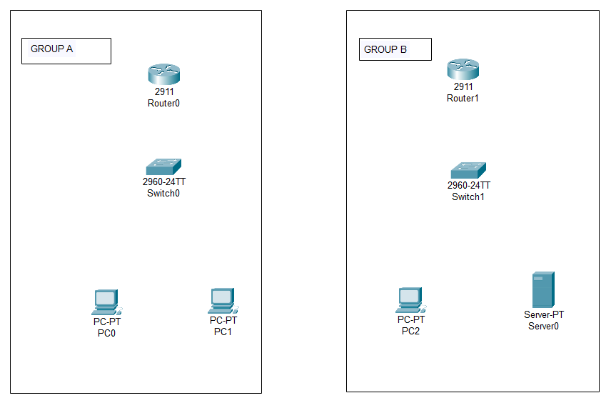

Step 2: Do connection with the help of straight through into the group a and group b and connect the both router with cross over cable.

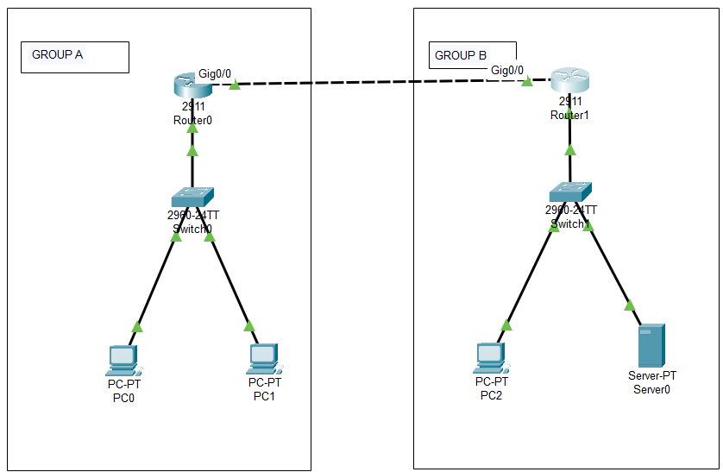

Step 3: Click on router then go to the config then give the ip as follow

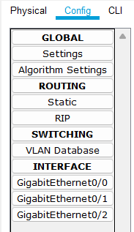

GROUP A

* Router—10.0.0.1 (gig0/1)

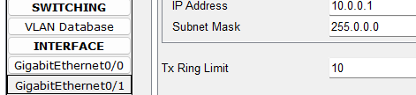

* Router--- 30.0.0.1 (gig0/0)

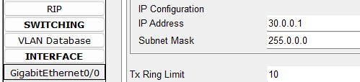

GROUP B

* Router – 20.0.0.1 (gig0/2)

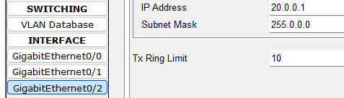

* Router – 30.0.0.2 (gig0/0)

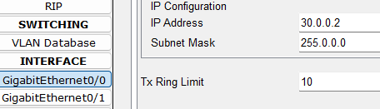

Step 4: Go to the desktop then ip configuration After it give the ip as follow into the both groups. Also give the server ip.

* Pc 0 – 10.0.0.2 (gateway 10.0.0.1) (server 20.0.0.3)

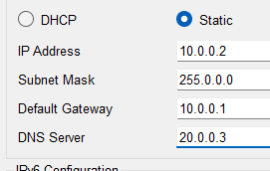

* Pc 1 – 10.0.0.3 (gateway 10.0.0.1) (server 20.0.0.3)
* Pc 2 – 20.0.0.2 (gateway 20.0.0.1) (server 20.0.0.3)
* Server – 20.0.0.3 (gateway 20.0.0.1) (server 20.0.0.3)

Step 5: Do the RIP into both routers.

GROUP A

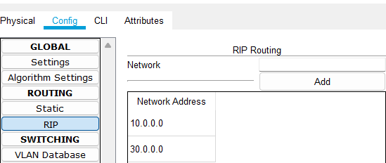

GROUP B

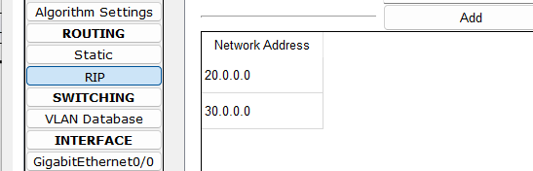

Step 6: Know go to the server then go to the services. Then go to the FTP.

Give the username, password and all rights then clivk on add.

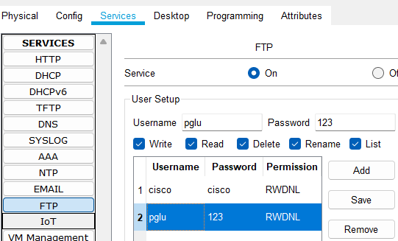

Step 7: Go to the pc 1 and click on the txt editor create a txt file.

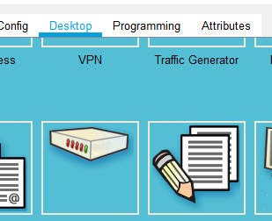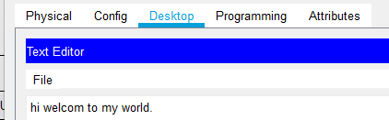

Step 8: Know go to the command prompt and follow the cmd.

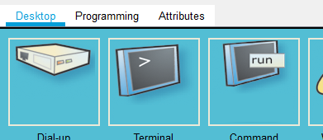

* Dir (show the available file)

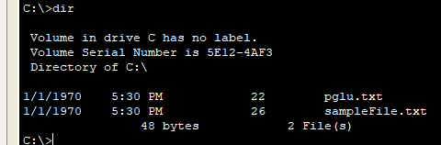

* ftp (access the server)

ftp 20.0.0.3 (20.0.0.3 is server ip)

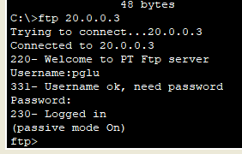

* Put (upload the file on server)

put pglu.txt

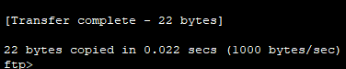

Step 9: Go to the pc 2 then go to the command prompt type as follow cmd.

* ftp

ftp 20.0.0.3 (20.0.0.3 is server ip)

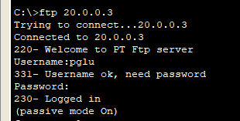

* get

get pglu.txt (get used for download a file and here pglu.txt is file)

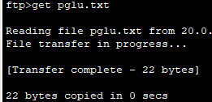

* dir (show the available file)

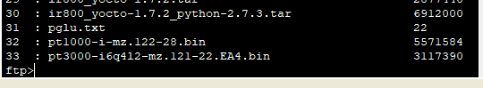

1. **Testing**

Testing a simulation for FTP service in a Cisco networking environment is a critical phase to ensure the accuracy of the model, the validity of results, and the effectiveness of any proposed optimizations. Below are key testing steps and considerations:

1. Verification of Simulation Setup:

* Topology Validation: Verify that the simulated network topology accurately represents the intended Cisco networking environment, including devices, connections, and configurations.
* Device Configuration: Ensure that Cisco devices within the simulation have been configured correctly, including routing, access control, and security settings.
* FTP Server Setup: Confirm that FTP servers in the simulation are configured accurately, matching real-world settings.



**7. Conclusion**

The simulation of FTP service within a Cisco networking environment is a complex endeavor that involves modeling, testing, and optimizing various aspects of network performance, security, and scalability. In conclusion, the simulation process offers several key takeaways and insights:

**Understanding Network Dynamics:** The simulation provides a deeper understanding of how FTP service interacts with the Cisco networking infrastructure. It reveals the complexities of routing, switching, security, and quality of service in a real-world context.

**Performance Optimization:** Through rigorous testing, the simulation identifies performance bottlenecks and provides opportunities for optimization. This may include fine-tuning QoS policies, load balancing, and security measures to enhance FTP service efficiency.

**Security Evaluation:** The simulation allows for the evaluation of security measures, such as access control lists (ACLs), firewall rules, and intrusion detection/prevention systems (IDPS). It helps assess the effectiveness of these measures in protecting FTP services from threats.

**Scalability Assessment:** Scalability testing determines the point at which the network or FTP service begins to experience performance degradation under increasing loads. This information is crucial for capacity planning and resource allocation.

**Error Handling and Resilience:** By simulating error scenarios and network failures, the simulation assesses how well the FTP service and network infrastructure handle disruptions. It helps identify weaknesses and opportunities for improving fault tolerance and error recovery.

**Continuous Improvement:** Simulation is not a one-time process but an iterative one. As the network evolves and new challenges arise, ongoing testing and optimization are essential to adapt to changing requirements and threats.

# References

[1] <https://www.netacad.com/>